Data Analytics with Hadoop

Assignment – Output Screenshots

1. Input 1



Output 1

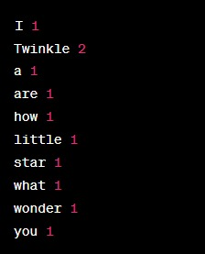

2. Input 2



Output 2

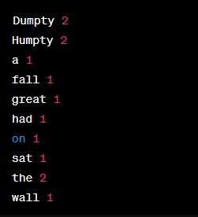

3. Input 3



Output 3

